**Exercise No:4**

**Date:14-10-2020**

**Aim:**

**To print the single string from two set of strings by swamping first two characters of each string.**

**Program:**

**def convert(s):**

**new=""**

**for x in s:**

**new+=x**

**return new**

**a=input()**

**b=input()**

**s1=a.strip()**

**s2=b.strip()**

**if(len(s1)>=2 and len(s2)>=2):**

**t1=list(s1)**

**t2=list(s2)**

**c1=t1[0]**

**c2=t1[1]**

**t1[0]=t2[0]**

**t1[1]=t2[1]**

**t2[0]=c1**

**t2[1]=c2**

**s1=convert(t1)**

**s2=convert(t2)**

**print(s1," ",s2)**

**else:**

**print("invalid")**

**Link:**

[**http://103.53.53.18/mod/vpl/forms/edit.php?id=234&userid=1684#**](http://103.53.53.18/mod/vpl/forms/edit.php?id=234&userid=1684#)

**Output:**

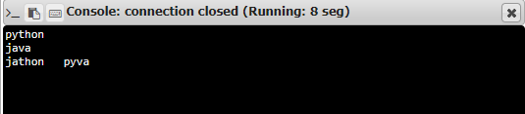

**Result:**

**Thus, the single string from two set of strings by swamping first two characters of each string is printed .**